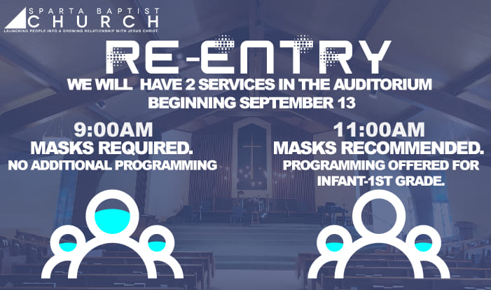
Next Steps for SBC – Fall 2020
As we continue to navigate this COVID pandemic together and strategically respond to the immense challenges it has presented, we want to take the opportunity to lay out our plan and explain how we got here.
For some, the steps we have taken to this point have been both too cautious and too slow. For others, there is concern that we have not been cautious enough. While we recognize the differing perspectives, we are grateful for the encouragement so many of you have offered. Thank you for your prayer, support, and patience. It has been an incredibly difficult season of ministry.
We have spent the last five months consulting with medical professionals including members of the Kent County COVID Task Force, local and regional church leaders, academic professionals, and many others to determine best practices as we have sought to carve out a path forward. We have referenced and integrated both the CDC recommendations and the Executive Orders sent down from the Governor’s Office. We believe the plan we have come up with serves to provide the necessary safety protocols for our most vulnerable, while at the same time respecting the various needs within our own congregation.
Offering a “mask required” service, where masks are expected to be worn throughout the entirety of the service, is a key part of our plan. While the vast majority of churches and church leaders we have consulted with have deemed this level of caution unnecessary, we believe it best meets our needs. While at the same time, we also believe that with maintaining social distancing, limiting mutual touching of common surfaces, and extensive sanitation we can also offer a safe “mask recommended” service with protocols similar to that of restaurants. We are encouraging masks to be worn while moving in and out of the auditorium and then can be taken off when seated. This service also provides an in-person option for the many who experience headaches and anxiety when wearing masks.
We have every expectation that there may be some questions and we welcome your feedback. We have sought to implement a plan that meets each member of our congregation where they are with differing levels of concern, different views on how those concerns should be managed, and how quickly we should move forward in light of the ongoing challenges COVID presents. We have been praying, consulting, discussing, and planning for several months and have confidence that this is the best path forward for us at this point. We also realize that with so much uncertainty our plans need to be fluid enough to be altered as appropriate.

Re-Entry Protocols:
- Special attention will be paid to sanitize the air and all surfaces before each service.
- It is designed to be a touch free environment with no passing of plates, social distancing layout in the auditorium, and greeters honoring your space as you enter.
- Greeters will also serve as ushers helping to seat from front to back upon entry and dismiss rows from rear to front.
- We ask that you wait until you are outside for extended conversations with one another.
- Children’s Ministry
  - Children are welcome and invited to participate in both services.
  - We will also offer auxiliary seating in the Common Ground Café and the Fireside Lounge for maximum flexibility.
  - There will be programming offered for newborn through 1st grade during the 11am service.
  - Interactive materials will be available for 2nd-5th graders in both the 9am and 11am services. (We hope to provide extended programming sometime in October.)
  - Check in during the 11am service will be in the nursery and in the gym.
- We will have music, videos, preaching, and a limited amount of corporate singing in each service.
- Services will run approximately 65-70 minutes.
- If you are not yet ready for re-entry or are experiencing any signs of sickness (fever, shortness of breath or difficulty breathing, sore throat, runny nose, etc.) we ask that you would join us from home for our live-streamed service at 11am.
- We plan to offer a “mask only” section in the auditorium during the 11am service.
Requests: We ask each of you to make a few crucial decisions as you Re-Enter:
- Choose to Be Positive: Keep an upbeat and hopeful outlook as we figure this out together.
- Choose to Pursue Unity: Love one another more than you do your individual preferences and perspective. Defer to one another whenever and wherever possible.
- Choose to Engage: We want to encourage you to choose a service and attend with your family. Have a great appreciation for the Ministry of Presence, realizing that your presence is a blessing to your church family. If you join on the livestream from home, we invite you to check-in with us via the SBCLink on the website.
- Choose to Serve: Be open to helping in potentially new and different ways in the short-term as we seek to figure out what is needed through this season.
- Choose to be Encouraging: Offer supportive feedback via the SBCLink on the Website, emails, phone calls, cards, etc. to our pastoral staff as you have the opportunity.
All for Him,
SBC Elder Board

